AP25110070198
S . Harshini Narayana

1.creat a structure called “student” with members name, age and student marks . Write a c program to input data for two students , display their information, and find the average of total marks

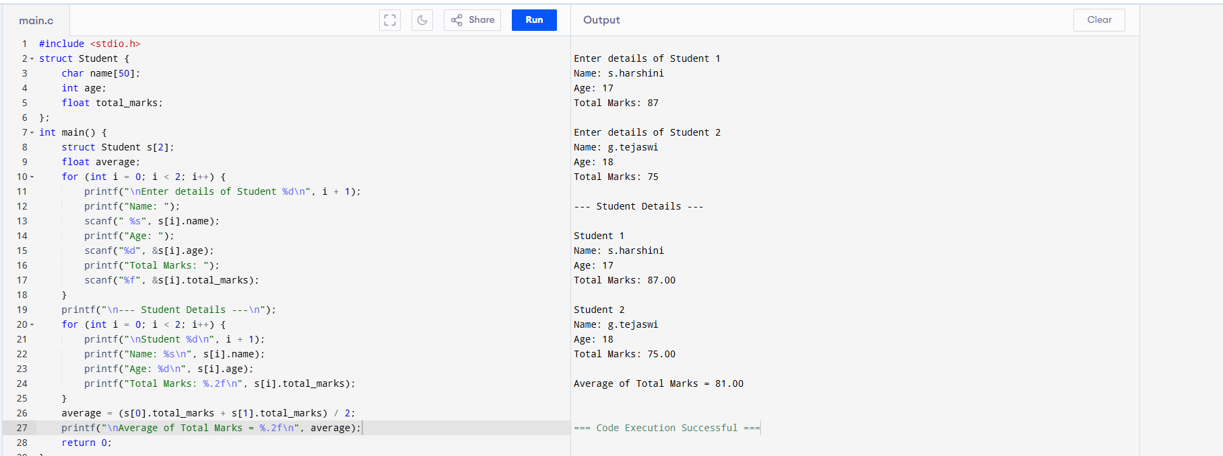

2.design the structure named “car” to store details like car ID, model and rental rate per day .write a c program to input for three cars ,calculate the total rental cost for specified number of days , and display the result.

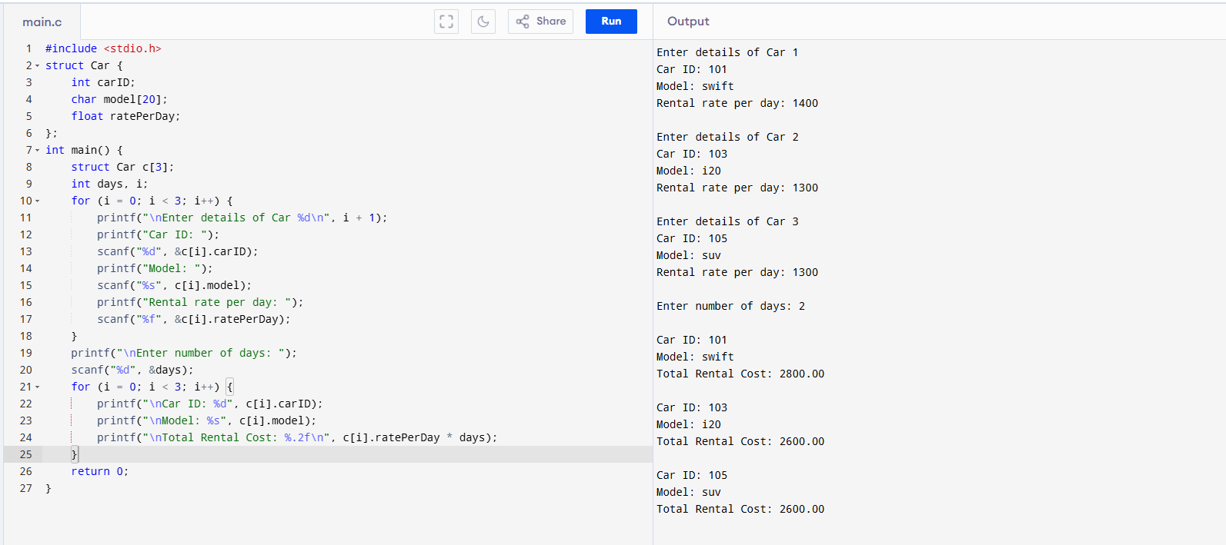

3.creat a structure named complex to represent a complex number with real and imaginary parts. Write a c program to add and multiply two complex numbers.

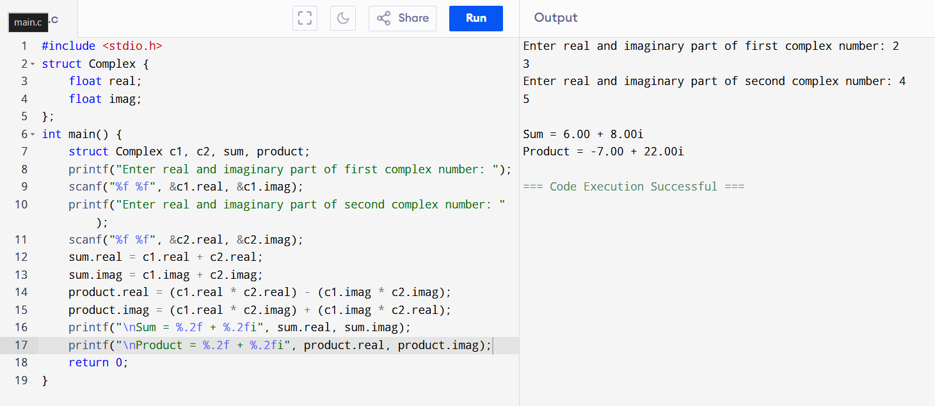

4.write a program in c to store and print the information of N employees using dynamic memory allocation and structures.

